***C PROGRAM LAB TASK-8***

1) Write a program in C to create and store information in a text file.

**#include <stdio.h>**

**#include <stdlib.h>**

**int main()**

**{**

**char str[1000];**

**FILE *fptr;**

**char fname[20]="test.txt";**

**printf("\n\n Create a file (test.txt) and input text :\n");**

**printf("----------------------------------------------\n");**

**fptr=fopen(fname,"w");**

**if(fptr==NULL)**

**{**

**printf(" Error in opening file!");**

**exit(1);**

**}**

**printf(" Input a sentence for the file : ");**

**fgets(str, sizeof str, stdin);**

**fprintf(fptr,"%s",str);**

**fclose(fptr);**

**printf("\n The file %s created successfully...!!\n\n",fname);**

**return 0;**

**}**

**Ouput:**

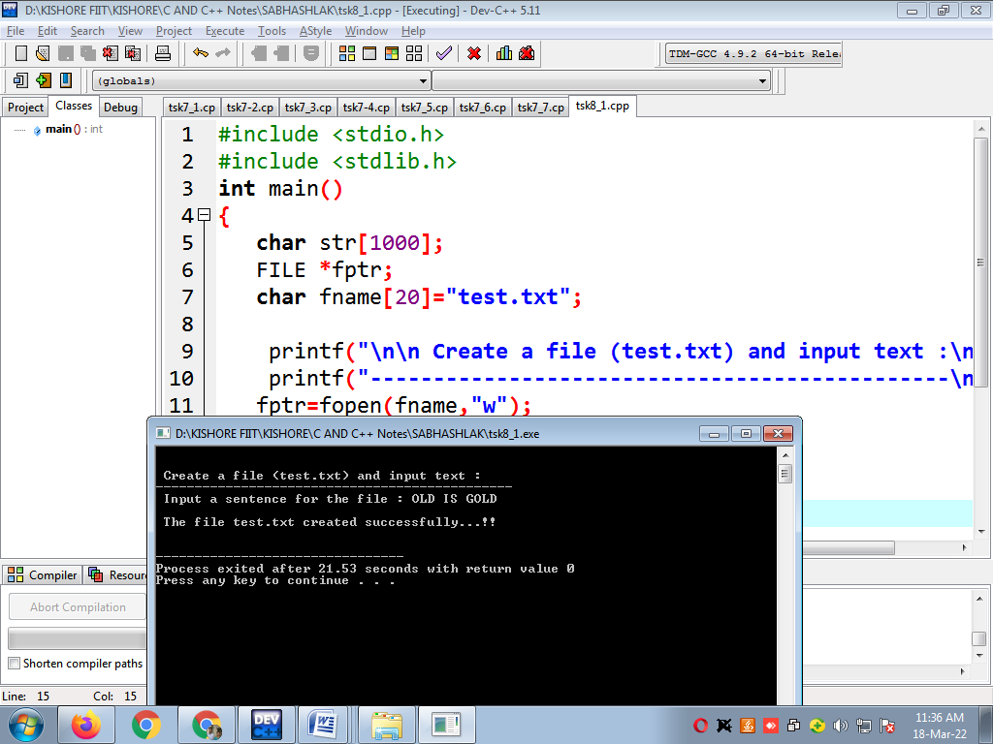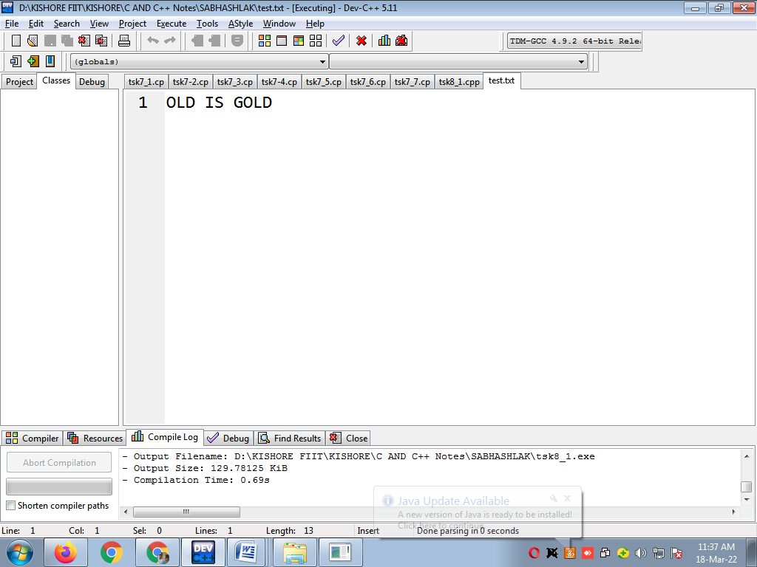

**2. Write a program in C to read an existing file.**

**#include <stdio.h>**

**#include <stdlib.h>**

**int main()**

**{**

**FILE *fptr;**

**char fname[20];**

**char str;**

**printf("\n\n Read an existing file :\n");**

**printf("------------------------------\n");**

**printf(" Input the filename to be opened : ");**

**scanf("%s",fname);**

**fptr = fopen (fname, "r");**

**if (fptr == NULL)**

**{**

**printf(" File does not exist or cannot be opened.\n");**

**exit(0);**

**}**

**printf("\n The content of the file %s is :\n",fname);**

**str = fgetc(fptr);**

**while (str != EOF)**

**{**

**printf ("%c", str);**

**str = fgetc(fptr);**

**}**

**fclose(fptr);**

**printf("\n\n");**

**return 0;**

**}**

**Output:**

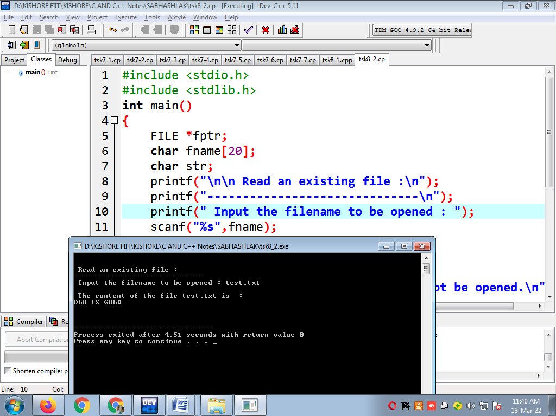

**3. Write a program in C to write multiple lines in a text file.   
#include <stdio.h>**

**int main ()**

**{**

**FILE * fptr;**

**int i,n;**

**char str[100];**

**char fname[20]="test.txt";**

**char str1;**

**printf("\n\n Write multiple lines in a text file and read the file :\n");**

**printf("------------------------------------------------------------\n");**

**printf(" Input the number of lines to be written : ");**

**scanf("%d", &n);**

**printf("\n :: The lines are ::\n");**

**fptr = fopen (fname,"w");**

**for(i = 0; i < n+1;i++)**

**{**

**fgets(str, sizeof str, stdin);**

**fputs(str, fptr);**

**}**

**fclose (fptr);**

**/*-------------- read the file -------------------------------------*/**

**fptr = fopen (fname, "r");**

**printf("\n The content of the file %s is :\n",fname);**

**str1 = fgetc(fptr);**

**while (str1 != EOF)**

**{**

**printf ("%c", str1);**

**str1 = fgetc(fptr);**

**}**

**printf("\n\n");**

**fclose (fptr);**

**return 0;**

**}**

**Ouput:**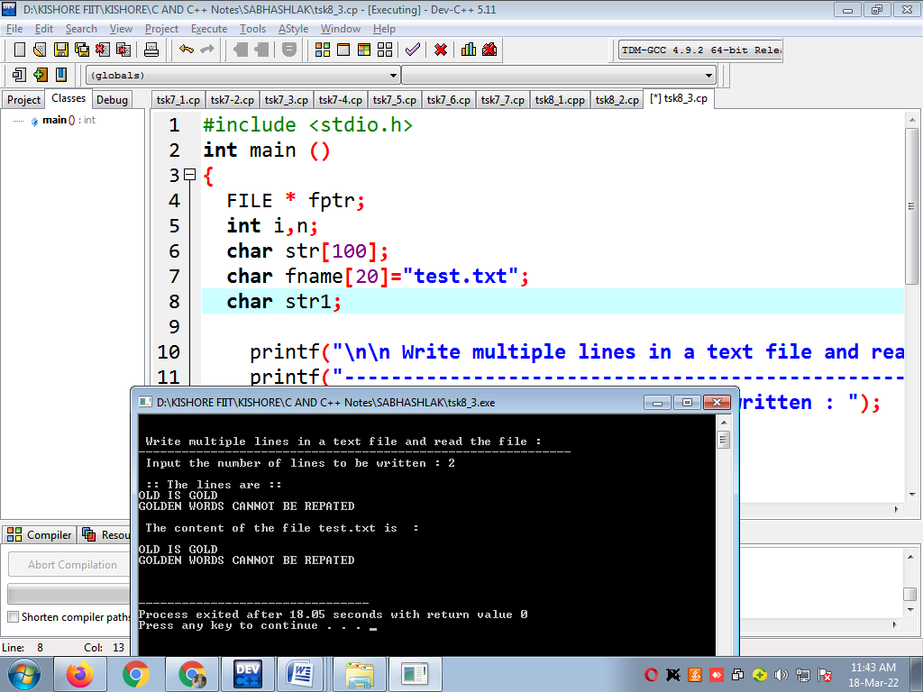

**4. Write a program in C to read the file and store the lines into an array.**

**#include <stdio.h>**

**#include <stdlib.h>**

**#include <string.h>**

**#define LSIZ 128**

**#define RSIZ 10**

**int main(void)**

**{**

**char line[RSIZ][LSIZ];**

**char fname[20];**

**FILE *fptr = NULL;**

**int i = 0;**

**int tot = 0;**

**printf("\n\n Read the file and store the lines into an array :\n");**

**printf("------------------------------------------------------\n");**

**printf(" Input the filename to be opened : ");**

**scanf("%s",fname);**

**fptr = fopen(fname, "r");**

**while(fgets(line[i], LSIZ, fptr))**

**{**

**line[i][strlen(line[i]) - 1] = '\0';**

**i++;**

**}**

**tot = i;**

**printf("\n The content of the file %s are : \n",fname);**

**for(i = 0; i < tot; ++i)**

**{**

**printf(" %s\n", line[i]);**

**}**

**printf("\n");**

**return 0;**

**}**

**Output:**

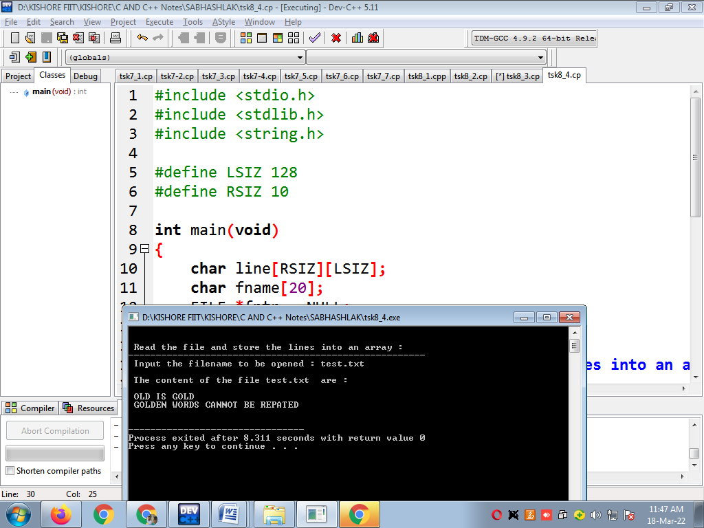

**5. Write a program in C to Find the Number of Lines in a Text File.**

**#include <stdio.h>**

**int main()**

**{**

**FILE *fileptr;**

**int count_lines = 0;**

**char filechar[40], chr;**

**printf("Enter file name: ");**

**scanf("%s", filechar);**

**fileptr = fopen(filechar, "r");**

**//extract character from file and store in chr**

**chr = getc(fileptr);**

**while (chr != EOF)**

**{**

**//Count whenever new line is encountered**

**if (chr == 'n')**

**{**

**count_lines = count_lines + 1;**

**}**

**//take next character from file.**

**chr = getc(fileptr);**

**}**

**fclose(fileptr); //close file.**

**printf("There are %d lines in %s in a file\n", count_lines, filechar);**

**return 0;**

**}**

**Ouput:**

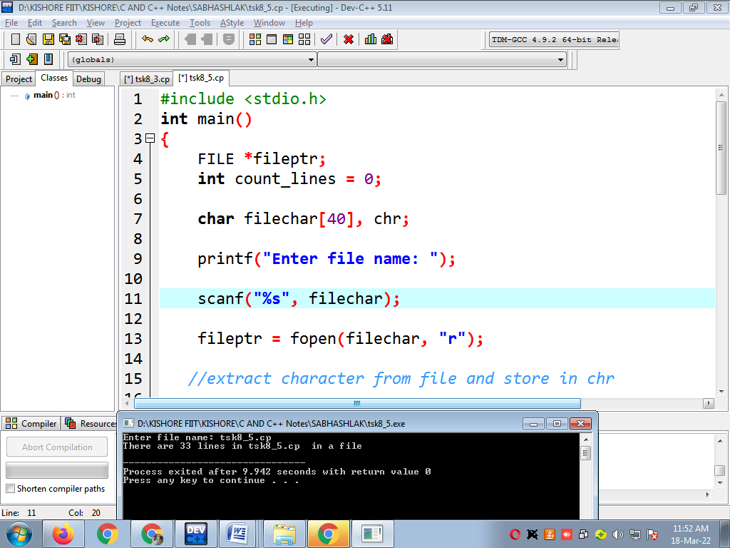

**6. Write a program in C to find the content of the file and number** o**f lines in a Text File**

**#include <stdio.h>**

**#include <stdlib.h>**

**#include <string.h>**

**#define LSIZ 128**

**#define RSIZ 10**

**int main(void)**

**{**

**char line[RSIZ][LSIZ];**

**char fname[20];**

**FILE *fptr = NULL;**

**int i = 0;**

**int tot = 0;**

**printf("\n\n Find the content of the file and number of lines in a Text File :\n");**

**printf("----------------------------------------------------------------------\n");**

**printf(" Input the file name to be opened : ");**

**scanf("%s",fname);**

**fptr = fopen(fname, "r");**

**/*--------------------- store the lines into an array ----------------*/**

**while(fgets(line[i], LSIZ, fptr))**

**{**

**line[i][strlen(line[i]) - 1] = '\0';**

**i++;**

**}**

**tot = i;**

**printf("\n The content of the file %s are : \n",fname);**

**for(i = 0; i < tot; ++i)**

**{**

**printf(" %s\n", line[i]);**

**}**

**/*---------------------------------------------------------------------*/**

**printf("\n The lines in the file are : %d\n",tot-1);**

**printf("\n");**

**return 0;**

**}**

**Output:**

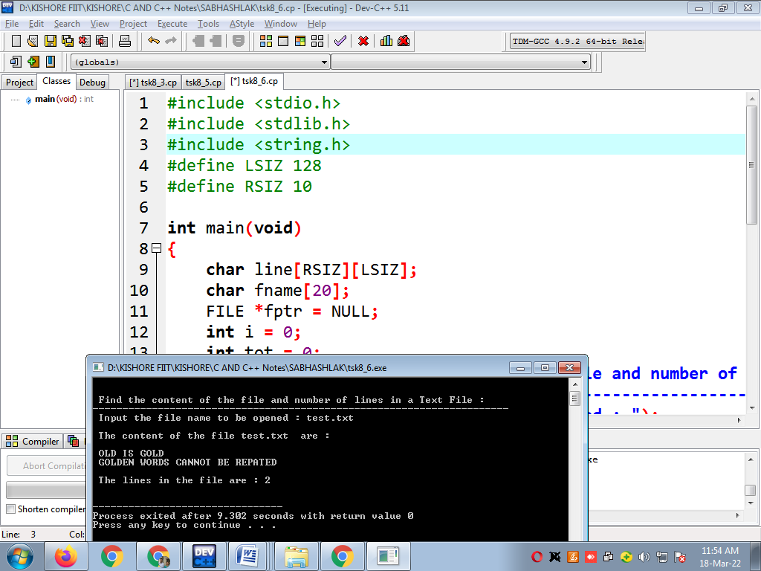

**7) Write a program in C to count a number of words and characters in a file.**

**#include <stdio.h>**

**#include <stdlib.h>**

**int main()**

**{**

**FILE *fptr;**

**char ch;**

**int wrd=1,charctr=1;**

**char fname[20];**

**printf("\n\n Count the number of words and characters in a file :\n");**

**printf("---------------------------------------------------------\n");**

**printf(" Input the filename to be opened : ");**

**scanf("%s",fname);**

**fptr=fopen(fname,"r");**

**if(fptr==NULL)**

**{**

**printf(" File does not exist or can not be opened.");**

**}**

**else**

**{**

**ch=fgetc(fptr);**

**printf(" The content of the file %s are : ",fname);**

**while(ch!=EOF)**

**{**

**printf("%c",ch);**

**if(ch==' '||ch=='\n')**

**{**

**wrd++;**

**}**

**else**

**{**

**charctr++;**

**}**

**ch=fgetc(fptr);**

**}**

**printf("\n The number of words in the file %s are : %d\n",fname,wrd-2);**

**printf(" The number of characters in the file %s are : %d\n\n",fname,charctr-1);**

**}**

**fclose(fptr);**

**return 0;**

**}**

**Output:**

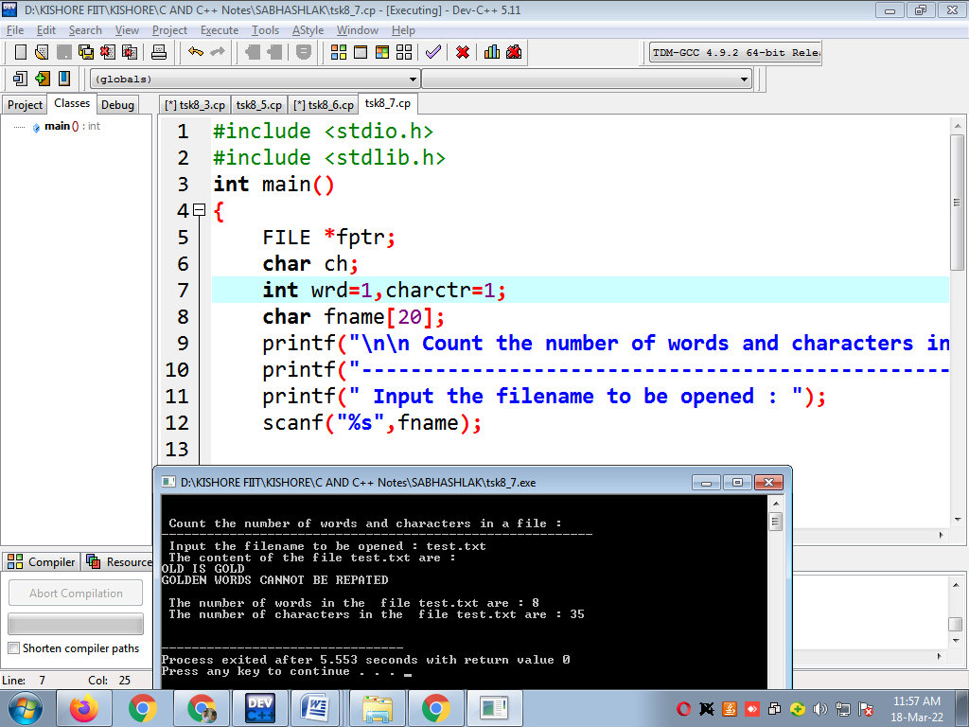

**8. Write a program in C to delete a specific line from a file.**

**#include <stdio.h>**

**#include <string.h>**

**#define MAX 256**

**int main()**

**{**

**int lno, ctr = 0;**

**char ch;**

**FILE *fptr1, *fptr2;**

**char fname[MAX];**

**char str[MAX], temp[] = "temp.txt";**

**printf("\n\n Delete a specific line from a file :\n");**

**printf("-----------------------------------------\n");**

**printf(" Input the file name to be opened : ");**

**scanf("%s",fname);**

**fptr1 = fopen(fname, "r");**

**if (!fptr1)**

**{**

**printf(" File not found or unable to open the input file!!\n");**

**return 0;**

**}**

**fptr2 = fopen(temp, "w"); // open the temporary file in write mode**

**if (!fptr2)**

**{**

**printf("Unable to open a temporary file to write!!\n");**

**fclose(fptr1);**

**return 0;**

**}**

**printf(" Input the line you want to remove : ");**

**scanf("%d", &lno);**

**lno++;**

**// copy all contents to the temporary file except the specific line**

**while (!feof(fptr1))**

**{**

**strcpy(str, "\0");**

**fgets(str, MAX, fptr1);**

**if (!feof(fptr1))**

**{**

**ctr++;**

**/* skip the line at given line number */**

**if (ctr != lno)**

**{**

**fprintf(fptr2, "%s", str);**

**}**

**}**

**}**

**fclose(fptr1);**

**fclose(fptr2);**

**remove(fname); // remove the original file**

**rename(temp, fname); // rename the temporary file to original name**

**/*------ Read the file ----------------*/**

**fptr1=fopen(fname,"r");**

**ch=fgetc(fptr1);**

**printf(" Now the content of the file %s is : \n",fname);**

**while(ch!=EOF)**

**{**

**printf("%c",ch);**

**ch=fgetc(fptr1);**

**}**

**fclose(fptr1);**

**/*------- End of reading ---------------*/**

**return 0;**

**}**

**Output:**

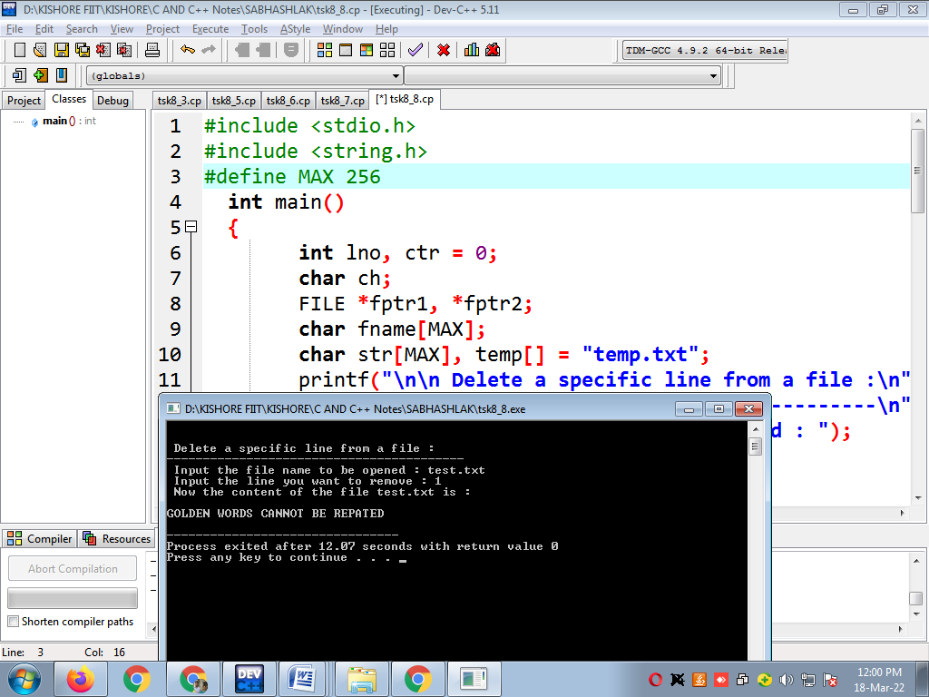

**9. Write a program in C to replace a specific line with another text in a file.**

**#include <stdio.h>**

**#include <string.h>**

**#define MAX 256**

**int main()**

**{**

**FILE *fptr1, *fptr2;**

**int lno, linectr = 0;**

**char str[MAX],fname[MAX];**

**char newln[MAX], temp[] = "temp.txt";**

**printf("\n\n Replace a specific line in a text file with a new text :\n");**

**printf("-------------------------------------------------------------\n");**

**printf(" Input the file name to be opened : ");**

**fgets(fname, MAX, stdin);**

**fname[strlen(fname) - 1] = '\0';**

**fptr1 = fopen(fname, "r");**

**if (!fptr1)**

**{**

**printf("Unable to open the input file!!\n");**

**return 0;**

**}**

**fptr2 = fopen(temp, "w");**

**if (!fptr2)**

**{**

**printf("Unable to open a temporary file to write!!\n");**

**fclose(fptr1);**

**return 0;**

**}**

**/* get the new line from the user */**

**printf(" Input the content of the new line : ");**

**fgets(newln, MAX, stdin);**

**/* get the line number to delete the specific line */**

**printf(" Input the line no you want to replace : ");**

**scanf("%d", &lno);**

**lno++;**

**// copy all contents to the temporary file other except specific line**

**while (!feof(fptr1))**

**{**

**strcpy(str, "\0");**

**fgets(str, MAX, fptr1);**

**if (!feof(fptr1))**

**{**

**linectr++;**

**if (linectr != lno)**

**{**

**fprintf(fptr2, "%s", str);**

**}**

**else**

**{**

**fprintf(fptr2, "%s", newln);**

**}**

**}**

**}**

**fclose(fptr1);**

**fclose(fptr2);**

**remove(fname);**

**rename(temp, fname);**

**printf(" Replacement did successfully..!! \n");**

**return 0;**

**}**

**Ouput:**

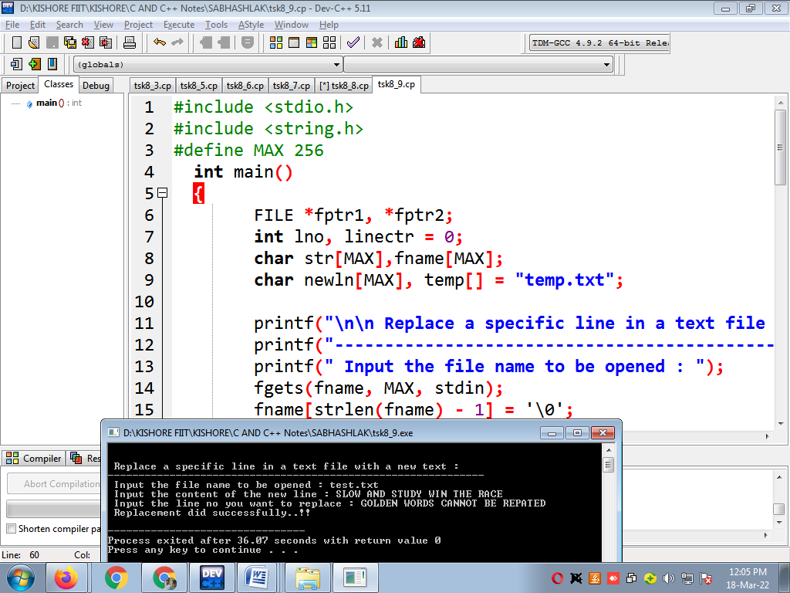

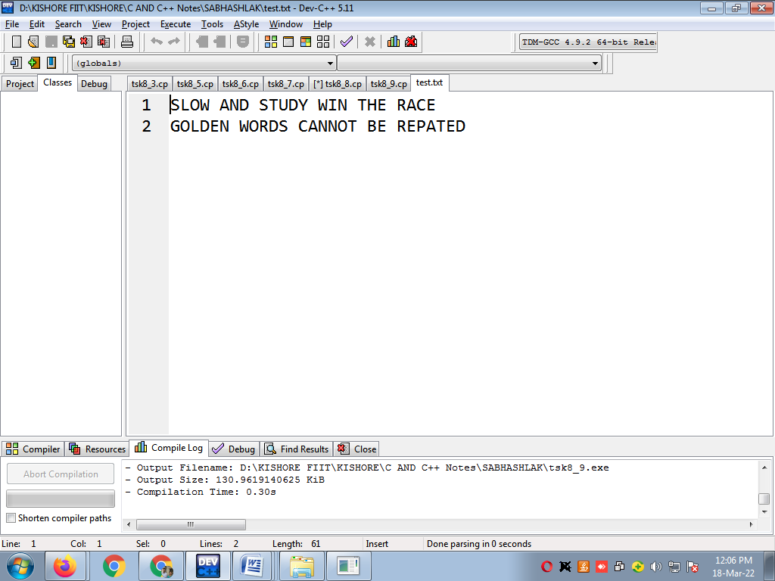

**10. Write a program in C to append multiple lines at the end of a text file.**

**#include <stdio.h>**

**int main ()**

**{**

**FILE * fptr;**

**int i,n;**

**char str[100];**

**char fname[20];**

**char str1;**

**printf("\n\n Append multiple lines at the end of a text file :\n");**

**printf("------------------------------------------------------\n");**

**printf(" Input the file name to be opened : ");**

**scanf("%s",fname);**

**fptr = fopen(fname, "a");**

**printf(" Input the number of lines to be written : ");**

**scanf("%d", &n);**

**printf(" The lines are : \n");**

**for(i = 0; i < n+1;i++)**

**{**

**fgets(str, sizeof str, stdin);**

**fputs(str, fptr);**

**}**

**fclose (fptr);**

**//----- Read the file after appended -------**

**fptr = fopen (fname, "r");**

**printf("\n The content of the file %s is :\n",fname);**

**str1 = fgetc(fptr);**

**while (str1 != EOF)**

**{**

**printf ("%c", str1);**

**str1 = fgetc(fptr);**

**}**

**printf("\n\n");**

**fclose (fptr);**

**//------- End of reading ------------------**

**return 0;**

**}**

**Output:**

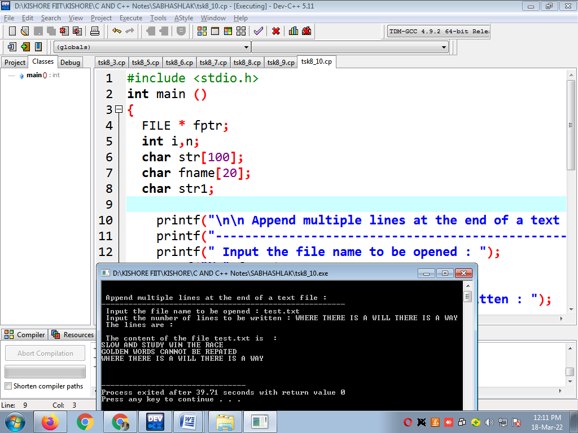

**11.Write a program in C to copy a file in another name.**

**#include <stdio.h>**

**#include <stdlib.h>**

**int main()**

**{**

**FILE *fptr1, *fptr2;**

**char ch, fname1[20], fname2[20];**

**printf("\n\n Copy a file in another name :\n");**

**printf("----------------------------------\n");**

**printf(" Input the source file name : ");**

**scanf("%s",fname1);**

**fptr1=fopen(fname1, "r");**

**if(fptr1==NULL)**

**{**

**printf(" File does not found or error in opening.!!");**

**exit(1);**

**}**

**printf(" Input the new file name : ");**

**scanf("%s",fname2);**

**fptr2=fopen(fname2, "w");**

**if(fptr2==NULL)**

**{**

**printf(" File does not found or error in opening.!!");**

**fclose(fptr1);**

**exit(2);**

**}**

**while(1)**

**{**

**ch=fgetc(fptr1);**

**if(ch==EOF)**

**{**

**break;**

**}**

**else**

**{**

**fputc(ch, fptr2);**

**}**

**}**

**printf(" The file %s copied successfully in the file %s. \n\n",fname1,fname2);**

**fclose(fptr1);**

**fclose(fptr2);**

**getchar();**

**return 0;**

**}**

**Ouput:**

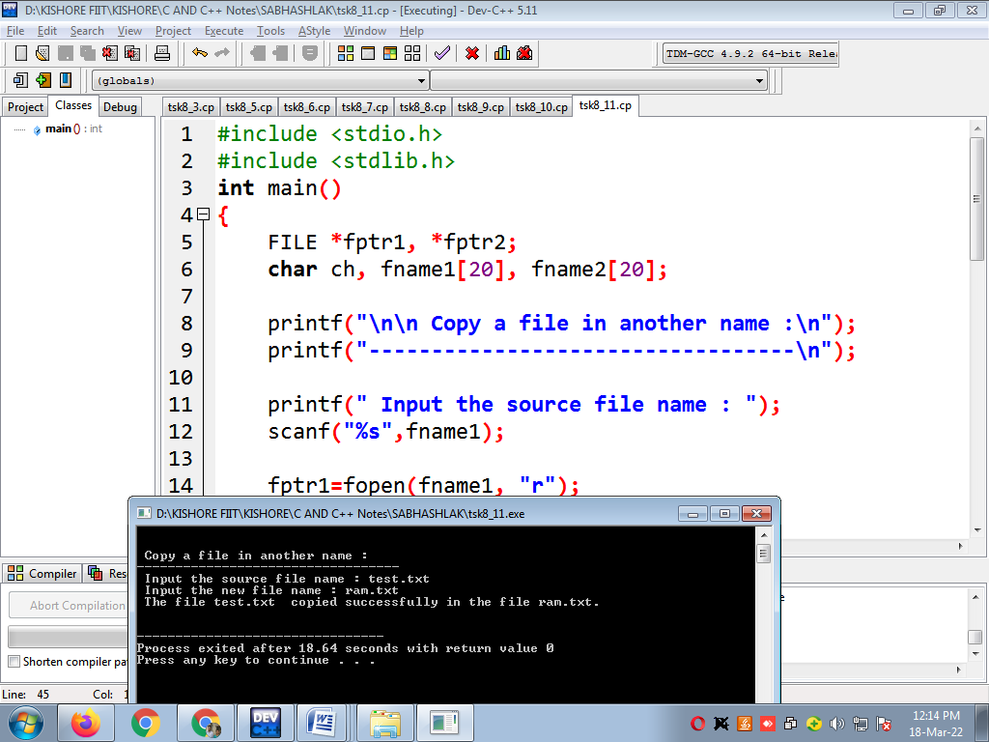



**12. Write a program in C to merge two files and write it in a new file.**

**#include <stdio.h>**

**#include <stdlib.h>**

**int main()**

**{**

**FILE *fold1, *fold2, *fnew;**

**char ch, fname1[20], fname2[20], fname3[30];**

**printf("\n\n Merge two files and write it in a new file :\n");**

**printf("-------------------------------------------------\n");**

**printf(" Input the 1st file name : ");**

**scanf("%s",fname1);**

**printf(" Input the 2nd file name : ");**

**scanf("%s",fname2);**

**printf(" Input the new file name where to merge the above two files : ");**

**scanf("%s",fname3);**

**fold1=fopen(fname1, "r");**

**fold2=fopen(fname2, "r");**

**if(fold1==NULL || fold2==NULL)**

**{**

**// perror("Error Message ");**

**printf(" File does not exist or error in opening...!!\n");**

**exit(EXIT_FAILURE);**

**}**

**fnew=fopen(fname3, "w");**

**if(fnew==NULL)**

**{**

**// perror("Error Message ");**

**printf(" File does not exist or error in opening...!!\n");**

**exit(EXIT_FAILURE);**

**}**

**while((ch=fgetc(fold1))!=EOF)**

**{**

**fputc(ch, fnew);**

**}**

**while((ch=fgetc(fold2))!=EOF)**

**{**

**fputc(ch, fnew);**

**}**

**printf(" The two files merged into %s file successfully..!!\n\n", fname3);**

**fclose(fold1);**

**fclose(fold2);**

**fclose(fnew);**

**return 0;**

**}**

**Output:**

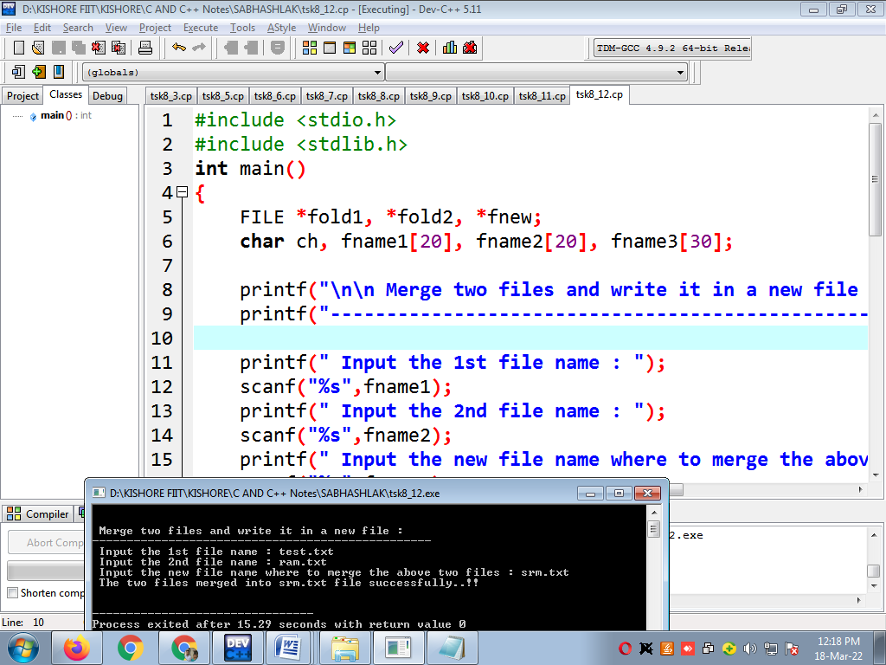

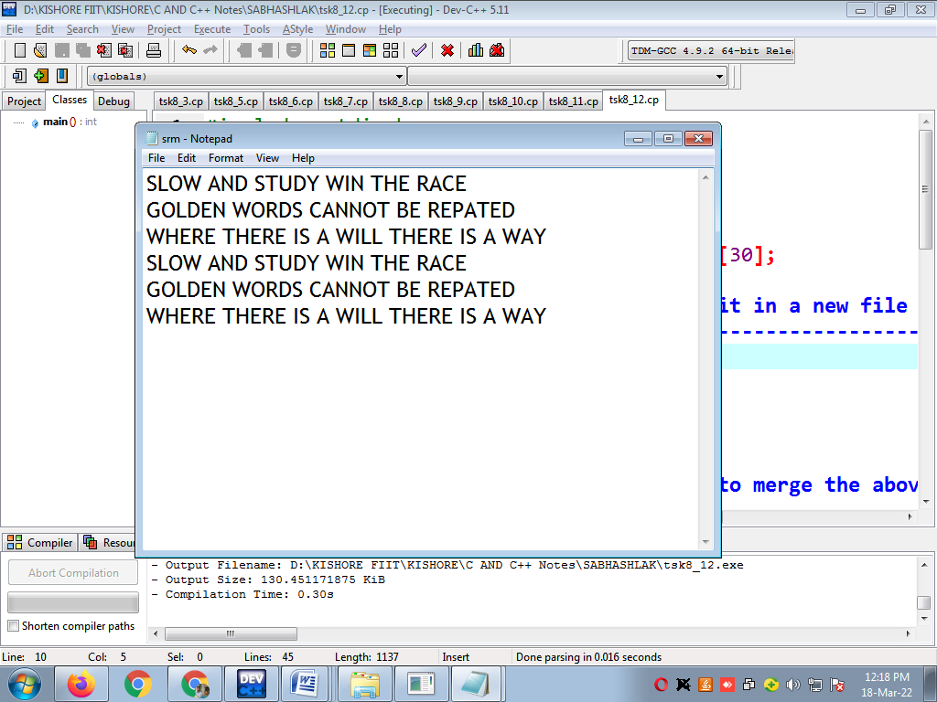

**13. Write a program in C to encrypt a text file.**

**#include <stdio.h>**

**#include <stdlib.h>**

**int main()**

**{**

**char fname[20], ch;**

**FILE *fpts, *fptt;**

**printf("\n\n Encrypt a text file :\n");**

**printf("--------------------------\n");**

**printf(" Input the name of file to encrypt : ");**

**scanf("%s",fname);**

**fpts=fopen(fname, "r");**

**if(fpts==NULL)**

**{**

**printf(" File does not exists or error in opening..!!");**

**exit(1);**

**}**

**fptt=fopen("temp.txt", "w");**

**if(fptt==NULL)**

**{**

**printf(" Error in creation of file temp.txt ..!!");**

**fclose(fpts);**

**exit(2);**

**}**

**while(1)**

**{**

**ch=fgetc(fpts);**

**if(ch==EOF)**

**{**

**break;**

**}**

**else**

**{**

**ch=ch+100;**

**fputc(ch, fptt);**

**}**

**}**

**fclose(fpts);**

**fclose(fptt);**

**fpts=fopen(fname, "w");**

**if(fpts==NULL)**

**{**

**printf(" File does not exists or error in opening..!!");**

**exit(3);**

**}**

**fptt=fopen("temp.txt", "r");**

**if(fptt==NULL)**

**{**

**printf(" File does not exists or error in opening..!!");**

**fclose(fpts);**

**exit(4);**

**}**

**while(1)**

**{**

**ch=fgetc(fptt);**

**if(ch==EOF)**

**{**

**break;**

**}**

**else**

**{**

**fputc(ch, fpts);**

**}**

**}**

**printf(" File %s successfully encrypted ..!!\n\n", fname);**

**fclose(fpts);**

**fclose(fptt);**

**return 0;**

**}**

**Output:**

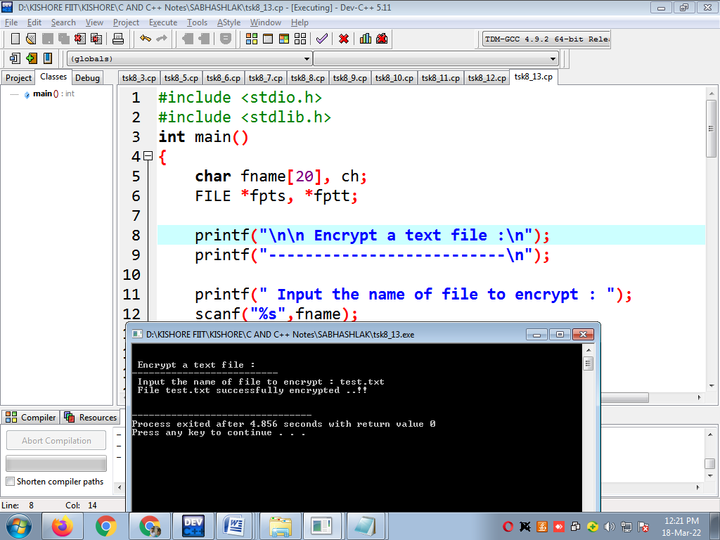

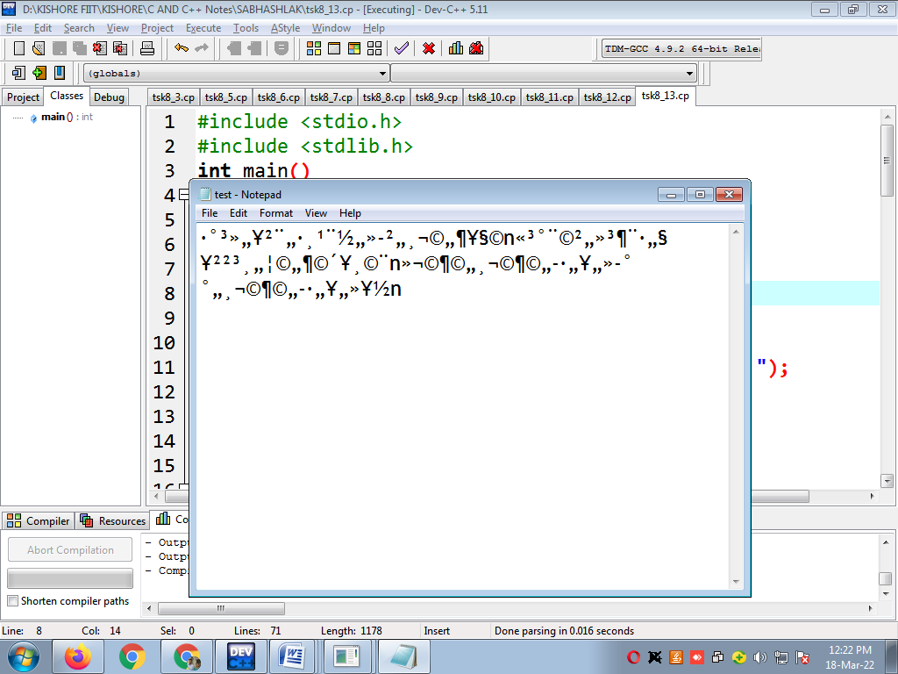

14. Write a program in C to decrypt a previously encrypted file file.

#include <stdio.h>

#include <stdlib.h>

int main()

{

char ch, fname[20];

FILE *fpts, *fptt;

printf("\n\n Decrypt a text file :\n");

printf("--------------------------\n");

printf(" Input the name of file to decrypt : ");

scanf("%s",fname);

fpts=fopen(fname, "w");

if(fpts==NULL)

{

printf(" File does not exists or error in opening..!!");

exit(7);

}

fptt=fopen("temp.txt", "r");

if(fptt==NULL)

{

printf(" File does not exists or error in opening..!!");

fclose(fpts);

exit(9);

}

while(1)

{

ch=fgetc(fptt);

if(ch==EOF)

{

break;

}

else

{

ch=ch-100;

fputc(ch, fpts);

}

}

printf(" The file %s decrypted successfully..!!\n\n",fname);

fclose(fpts);

fclose(fptt);

return 0;

}

Output:

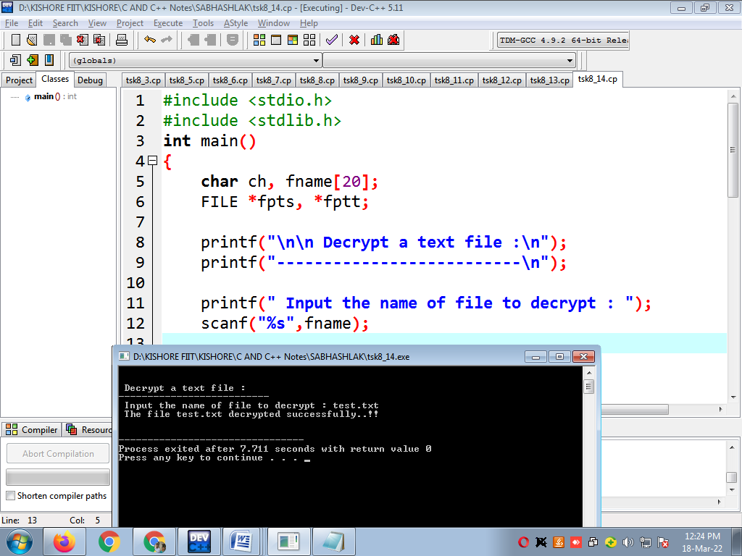

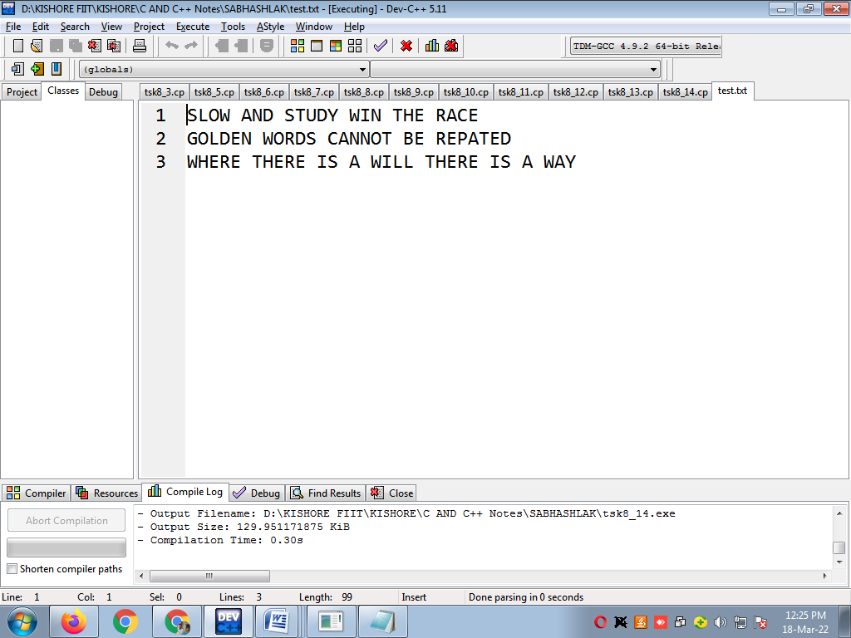

**15. Write a program in C to remove a file from the disk.**

#include <stdio.h>

int main()

{

int status;

char fname[20];

printf("\n\n Remove a file from the disk :\n");

printf("----------------------------------\n");

printf(" Input the name of file to delete : ");

scanf("%s",fname);

status=remove(fname);

if(status==0)

{

printf(" The file %s is deleted successfully..!!\n\n",fname);

}

else

{

printf(" Unable to delete file %s\n\n",fname);

}

return 0;

}

Output:

